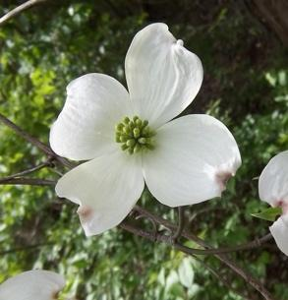 | "Buddy"® Poppy/National Home  January-February 2024  “SHOW ME TEAMWORK  …AS WE WORK FOR OUR VETERANS” | Janet Barlar  10865 C0 Rd 3310  Rolla, Mo. 65401  573-261-1948  baraux1953@yahoo.com

*"Buddy"® Poppy/National Home Trivia*
The Poppy movement was inspired by Canadian Army Col. John McCrae’s famous poem, “In Flanders Fields.” Poppies were originally distributed by the Franco-American Children’s League to benefit children in the devastated areas of France and Belgium following WWI.
In 1922, VFW conducted a campaign and got Poppies from France. Members soon discovered it took too long to get the flowers in from France and they came up with a better idea. Disabled, hospitalized and aging veterans could make the paper flowers and ship them out to the members for distribution.

"Buddy"® Poppy
Happy New Year! I hope everyone had a safe and joyous Christmas. Time seems to be flying by! There are only four more months to get all our events done and to get our reporting done for the 2023-2024 year. It just doesn’t seem possible. Everyone has done a fantastic job, and I couldn’t be prouder of our Auxiliaries.
Feb.9-11, 2024 is our Winter Conference of Administration meeting and our next Buddy Poppy Display contest. The theme is Patriotic. The displays will be used as some of the table decorations for the Voice of Democracy banquet. Be creative and think outside the box! If you DO NOT want your display used for this purpose and want it back, please let me know.
I want to remind everyone that there are to be NO Post or Auxiliary numbers included in your display. There are to be NO pictures of Post or Auxiliary members or pictures of your Post included in your display. If you have any questions about what can be included in your display, please ask. The last thing I want to do is disqualify any display.

National Home

The VFW National Home was spotlighted on the Lifetime movie channel in November. If you did not see this special hosted by Montel Williams, all you have to do is log on to YouTube and search VFW National Home and look for the video titled Military Makeover: Operation Career with VFW National Home. It was outstanding and very informative. A must see!
I did not realize when I went to YouTube and searched VFW National Home, how many different videos there were about the National Home. Please take some time and check it out. It is well worth the time and has great information that can be used to promote the National Home.
As I am reading through the reports on MALTA for Buddy Poppy/National Home, I am finding that many of our Auxiliaries are paying for a Life Membership to the National Home monthly for one member. They hold a drawing at their Auxiliary meeting for this membership. What a great idea! I know that some Auxiliaries cannot afford to do this monthly but consider doing a yearly drawing for a Life Membership. The cost is just $50.00. It would be money well spent. I am going to take this idea to my District and ask that at each one of our District meetings, we hold a drawing for one Life Membership.
I look forward to seeing everyone in February. Keep up the great work and don’t forget to send me pictures!

